**Dimension | Progress Report — September 2019**



**Technical Progress**

● The dynamic node proposal application and voting process has been tested.

In the test proposal process, the joining and removal of each dynamic node is determined by the vote of the voting account in the whole network. After the agreement is reached, the block schedule is updated, and a new schedule is executed in the next cycle.

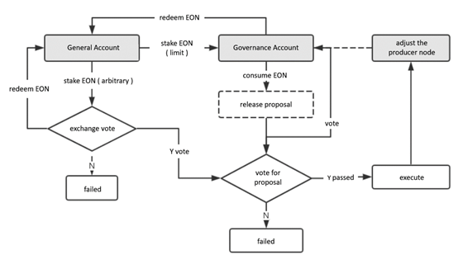

● ConsensusX framework iteration and optimization

The integration test is done for the custom consensus algorithm interface supported by the consensus engine.

● Two types of ConsensusX scenarios were tested.

Scenario 1: For nodes that pre-define consensus algorithms, when the proposal is voted through, they switch the main-net algorithm and produce the node at the specified block height.

Scenario 2: If the node does not pre-define a new consensus algorithm, the node exits and loads the new algorithm in batches. When the upgraded block height is reached, it switches new consensus algorithm and participates in the whole network node.

At the same time, nodes that have not effectively upgraded the new algorithm will be marked as failed nodes and cannot participate in node production. The test passed.

● HPoS-R consensus enters pre-research stage

The second round of improvement and verification was based on the HotStuff algorithm model.

● Bug fix and optimization performance for Dynamic Node and ConsensusX modules in C.H.A.O.S.

● The test network startup preparation is basically ready, and the node construction document is completed.